# Cut Your Pictures - Game Design Document

# Game Overview

Game Concept:

The player cuts out Pieces from a paper with a cutter knife to complete Pictures. Framed Pictures than placed on a wall, which gives a rewarding feeling of completeness.

Genre: Casual

Target Audience: Casual gamers of any age, who like collectibles and paintings.

Game Flow Summary :

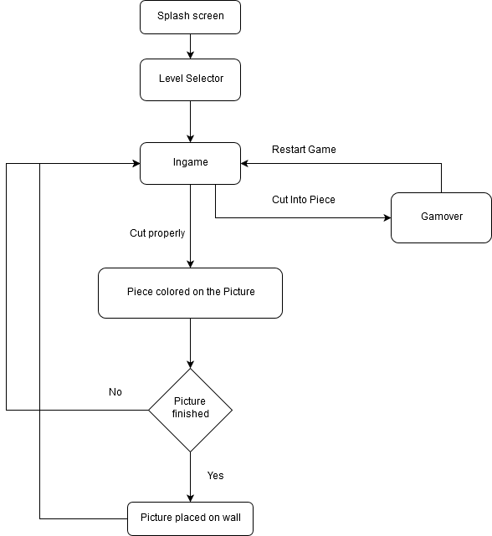

Look and Feel : Cartoony, simple design, 2D.

# Gameplay and Mechanics

* Gray, transparent silhouettes of the to be completed Pictures is present on the wall for uncompleted Pictures.
* The objective is to finish all Picture on the wall by cutting out the Pieces of a Picture one by one/level by level.
* 5 Piece is required for one Picture. After a Picture is finished it is placed on the wall with an animation.
* On a level, after a few seconds, a cutter knife is placed on the dashed line around the Piece to cut. The movement of the cutter is automatic, it goes slowly, the user has to rotate it with buttons, so he/she cuts on the dashed line as close as possible.
* A bigger difference from the dashed line, or cutting into the image leads to the failure of the level.
* The player has 3 buttons to tap:
  + *Rotate left/right*: rotate the cutter a few degrees.
  + *Freeze*: The cutter stops moving, so the player has enough time to properly rotate it. It is useful, when a high degree rotation is needed, and the player won’t have enough time to rotate otherwise. A predefined amount of Freezes are available on each level.

# Media

Images:

* Cutter,
* Frame for a paintings,
* Pieces of the 10 Painting, the themes are:
  + Landscape,
  + Holiday,
  + Food
  + Animals,
  + Sport,
  + Space
  + Reproduction of famous paintings
  + Electronics,
  + City
  + etc.

Audio:

* Sound of cutting
* Button tick
* Background music

# Levels

50 levels: 10 stages with approximetly 5 level per stage.

# Interface

Settings:

* Turn on/off music
* Turn on/off sound

Screen plans:

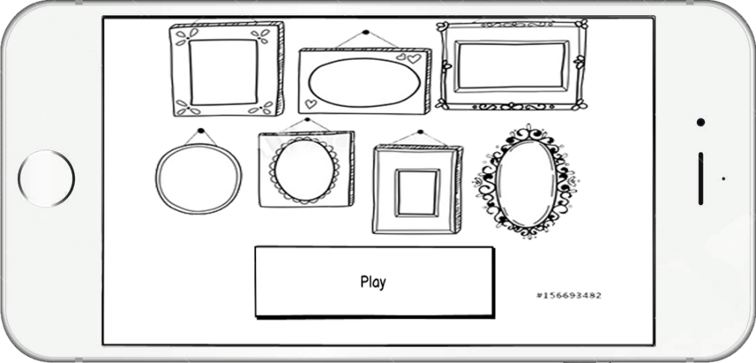

1. Menu

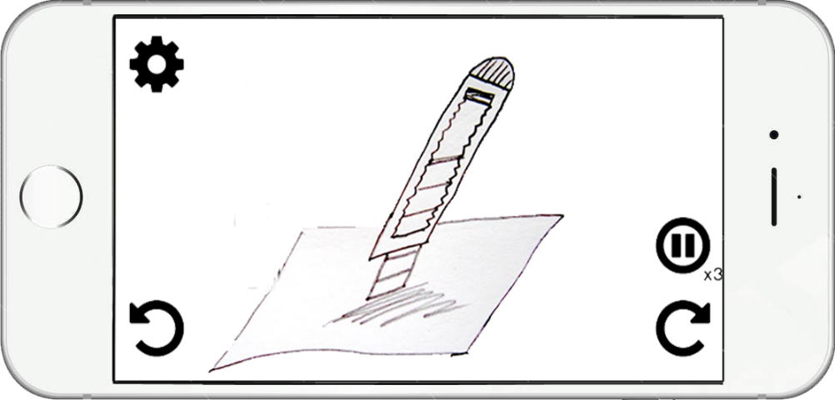

2. Ingame

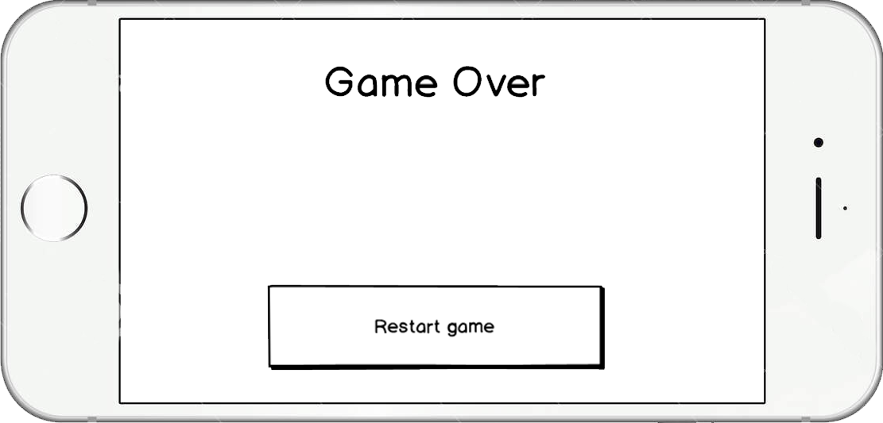

3. Game Over

# Technical

Engine: Unity 2019.2.14f1

Android:

* *Hardware*: Xiaomi Redmi Note 4 (<https://www.gsmarena.com/xiaomi_redmi_note_4-8531.php>)
* *Software*: Android 7.0

iOS:

* *Hardware*: ??
* *Software*: ??

# Economy

* The game is free to download/play.
* It shows an ad after each level.
* Avoiding to fail on a level (by cutting the picture) or claiming a Freeze (by hitting the Freeze button when there are none left) can be obtained if you accept to watch a video.